# **EXPLORATOTY DATA ANALYSIS FOR TOURISM DATA**

#TOP 10 MOST VISITED ATTRACTIONS

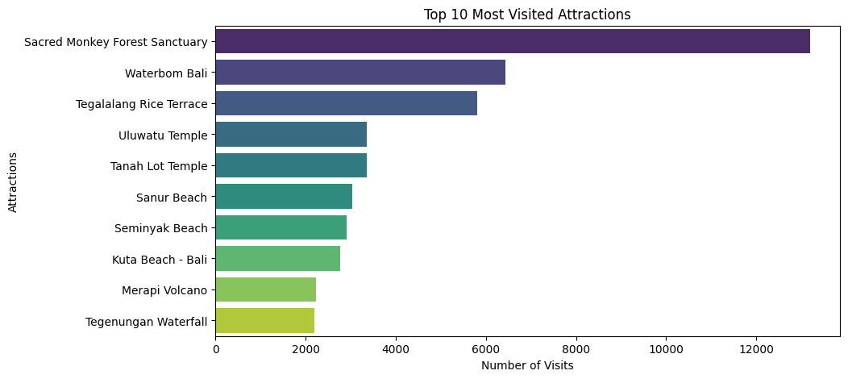

#TOURIST VISITS BY COUNTRY

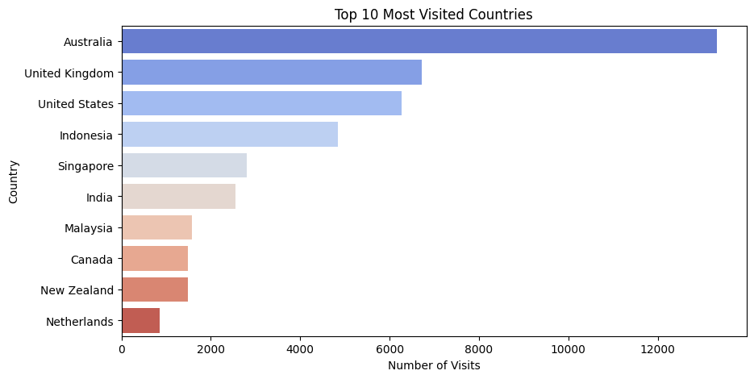

#MOST COMMON VISIT MODES

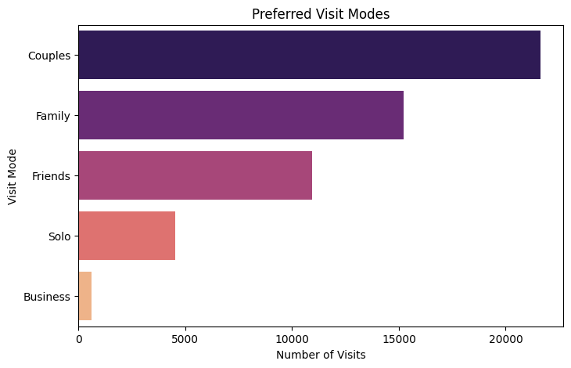

#MONTHLY VISITS DISTRIBUTION

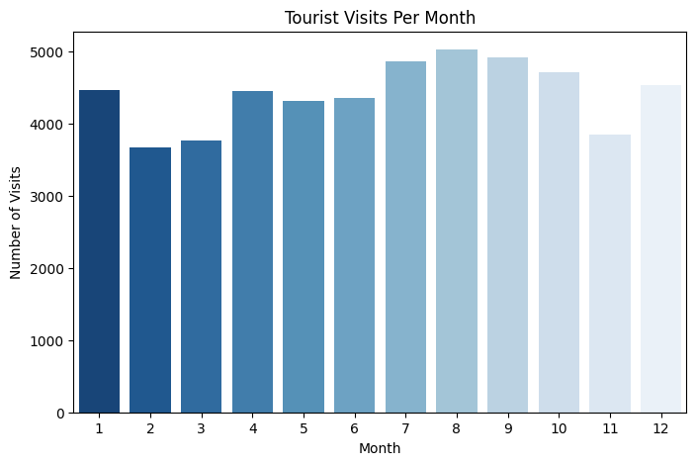

#AVERAGE RATING FOR TOP 10 ATTRACTIONS

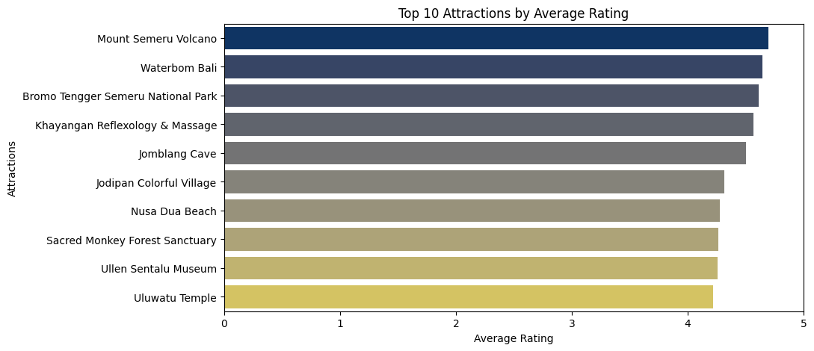

#AVERAGE RATING BY VISIT MODE

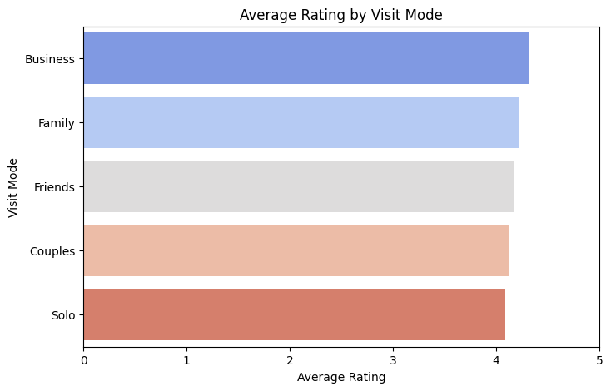

**# TOP 10 COUNTRIES WITH HIGH RATING**

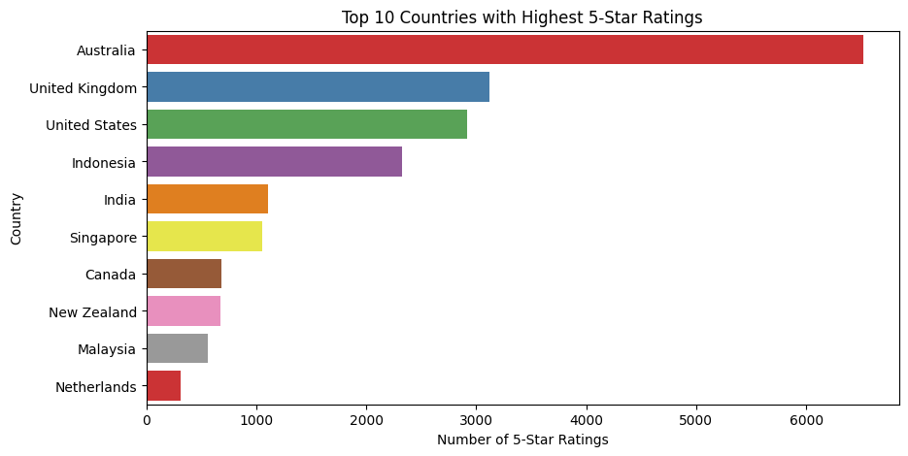

**#VISIT MODE PREFERENCE BY CONTINENT**

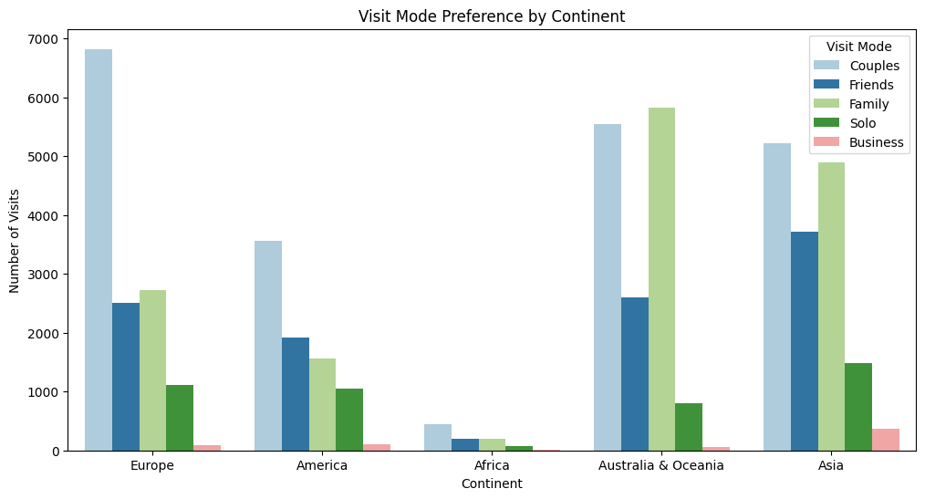

**#AVERAGE RATING BY ATTRACTION TYPE AND VISIT MODE**

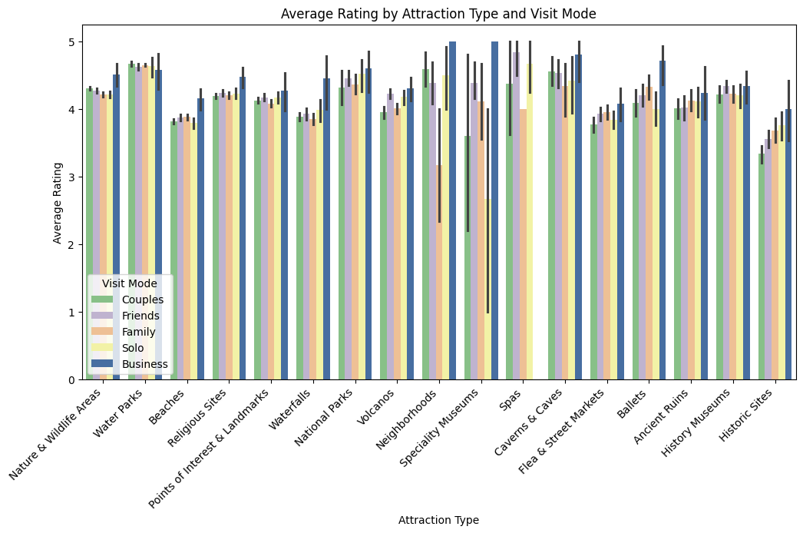

**#DISTRIBUTION OF RATING**

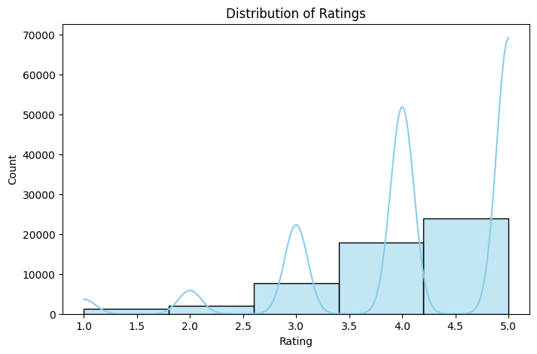

#DISPLAY THE VISIT COUNT PER MONTH

